 

**COLLEGECODE:9623**

**COLLEGENAME:AMRITACOLLEGEOFENGINEERING AND TECHNOLOGY**

**DEPARTMENT**:**COMPUTERSCIENCEANDENGINEERING STUDENT NM-ID: 12A034CC55E85E1BD8C491A91B2BC928 ROLL NO:962323104010**

**DATE:6-10-2025**

**CompletedtheprojectnamedasPhase5TECHNOLOGY PROJECT NAME : Employee Directory with Search**

**SUBMITTEDBY,**

**NAME:R.N.AHILESHRAJA**

**MOBILE NO: 900356091**

**FinalDemoWalkthrough**

# LandingPage:

Displaysallexistingemployeesinatabularformat. Search bar filters records dynamically.

# LoginPage:

OnlyadminscanaccessCRUDfunctions. Implemented using Flask-Login.

# AddEmployeePage:

FormcollectsemployeeID,name,department,designation,email,phone. Validations ensure data accuracy.

# Edit/DeleteEmployee:

Admincanupdateexistingrecordsorremoveentries.

# SearchBar:

Real-timefilteringusingAJAXrequests.

# LogoutFeature:

Endssessionsecurelyandreturnstologinpage. System Architecture

ArchitectureType:MVC(Model–View–Controller) Layer Component Description

ModelDatabase (MySQL) Storesemployeerecords. View HTML / CSS / JS Displays dynamic pages to user.

Controller Flaskroutes&API Handleslogic&communication.

# DataFlow:

1. UserrequestsanactionviaUI.
2. Flaskroutesprocesstherequest.
3. MySQLq
4. ResponsesentbackasJSON→renderedonpage. Backend Implementation

# FlaskAppStructure:

/employee_directory

├── app.py

├──static/

├──templates/

├──models/

├── routes/

├── database.py

└──config.py

# KeyAPIs:

GET /employees – List employees POST/employees–Addemployee

PUT /employees/<id> – Update employee DELETE/employees/<id>–Deleteemployee GET /search?name=... – Search employee

LibrariesUsed:Flask,Flask-SQLAlchemy,Flask-Login,Jinja2

---

FrontendImplementation

HomePage:Displaysemployeetablewithsearchandpagination. Form Pages: Bootstrap forms for adding/editing records.

# JavaScriptFeatures:

Fetch API calls to Flask endpoints. DOMmanipulationforliveupdates. Validation before submission.

CSSDesign:Clean,minimal,responsivelayout.

Icons/UI:FontAwesome+Bootstrapiconsforclarity.

# ScreenshotsDescription:

(Insertrealscreenshotslater–textplaceholdersbelow)

1. HomePage:Employeelisttablewithsearchbar.
2. AddEmployee:Formforaddingnewemployee.
3. EditEmployee:Formpre-filledwithcurrentdata.
4. DeleteConfirmation:Popuptoconfirmdeletion.
5. LoginPage:Adminloginform.
6. Dashboard:Overviewoftotalemployees&departments.
7. SearchResults:Filteredlistappearinginreal-time.

---

**Testing andValidation**

# UnitTests:

VerifiedCRUDendpoints(POST,GET,PUT,DELETE). Tested authentication and session flow.

# IntegrationTests:

Checkedcommunicationbetweenfrontendandbackend APIs.

# UITesting:

Manualtestingondesktop+mobilebrowsers.

# PerformanceCheck:

Searchfunctiontestedon1000+records.

# Result:

Allmodulesperformed withinacceptablelimits.

---

Challenges&Solutions

Challenge Description Solution

DatabaseConnectionErrors Deploymentcausedenvironment issuesUsedenvironmentvariables

+SQLAlchemypooling

SlowSearch Largedatasetqueriesdelayedresults Addedindexesandqueryoptimization

UI Scaling Interfacebrokeonmobiledevices UsedBootstrapgridsystem

Authentication Bugs Session timeout & redirect issues IntegratedFlask-Loginsession handler

APIIntegrationInconsistentJSONformats StandardizedAPIresponseswithschemas

---

**GitHubREADME&SetupGuide**

# SetupSteps:

1. Gitclone <https://github.com/Ahilesh2005/Employee-directory-with-search>
2. cdemployee-directory
3. python-mvenvvenv
4. venv\Scripts\activateorsourcevenv/bin/activate
5. pipinstall-r requirements.txt
6. ConfigureDBin.envor config.py
7. pythonsetup_db.py
8. pythonapp.py Deployment:

Push to GitHub → Deploy on Render / Heroku. Setenvironmentvariables(DB_URI,SECRET_KEY). Test live link.

---

# FinalSubmissionandConclusion

RepositoryLink:

<https://github.com/Ahilesh2005/Employee-directory-with-search/tree/main>

Deployed URL:

<https://employee-directory-with-search.vercel.app/>

Conclusion:

The project successfully meets the objective Of creating a searchable,scalable,and user-friendly employee directory.

Through modular design and FlaskAPIintegration,it demonstrates efficient data handling and real- time interaction.

Future improvements include advanced filters,role-based access,and integration with external HR API.

GITHUB: <https://github.com/Ahilesh2005/Employee-directory-with-search>

SCREENSHOT:

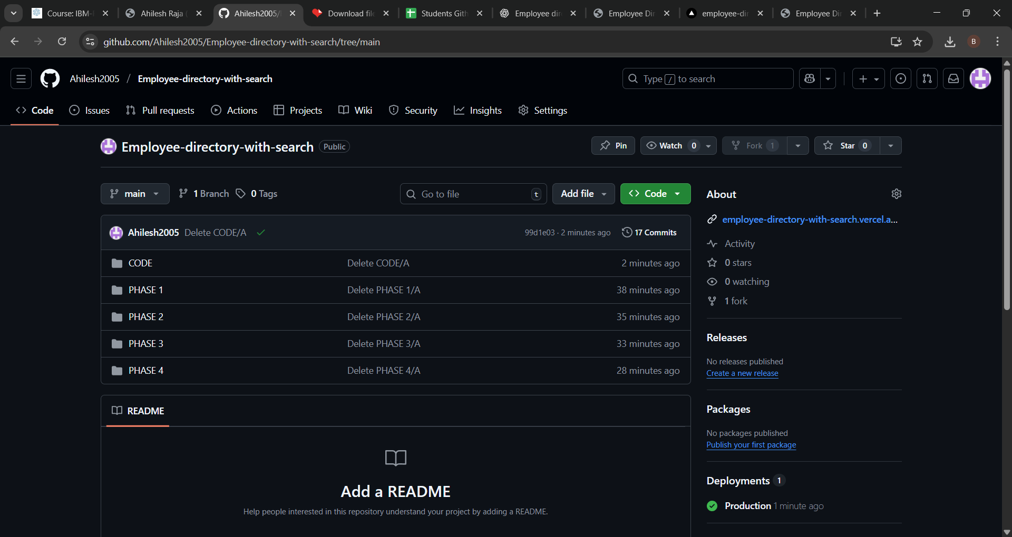

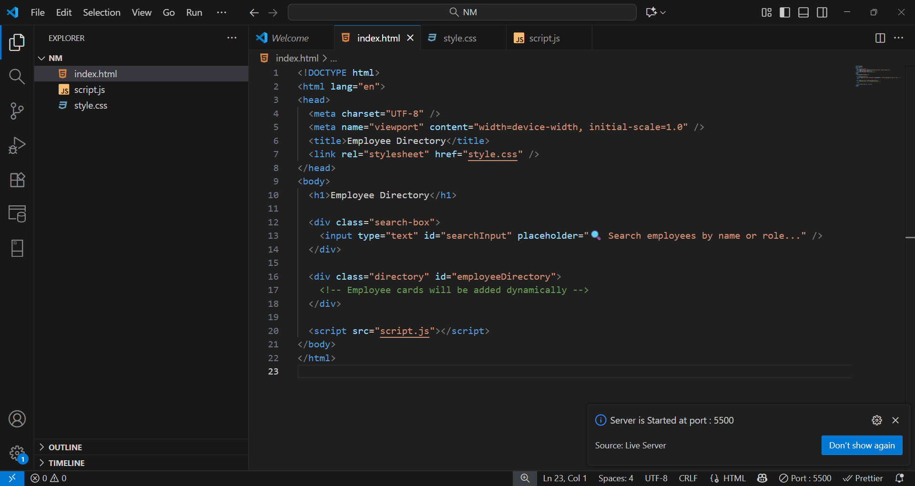

WEBSITE:

